**Traffic Source Analysis**

U**sing**

**UTM Parameters**



Made By:

Sushma Gupta

Traffic Source Analysis using Utm Parameters

1. Utm stands for  **Urchin Tracking Module**. Also called a “**UTM** parameter,” a **UTM** code is a portion of text added to the end of a URL that enables us to track visits to that URL.
2. These could be visits inspired byour social media posts, emails, pay-per-click campaigns — basically anytime we want to know where traffic is coming from

Example:

*http://yoururl.com/landingpage?utm_campaign=socialmedia &utm_medium=social&utm_source=twitterspan>*

* campaign=social media – This identifies our campaign and organizes our analytics by placing different content in separate areas.
* medium=social – Identify the type of [medium](https://www.optimizesmart.com/understanding-channels-in-google-analytics/#a1) that we’re featuring the link on. An example, other than social media, could be “email.”
* source= twitter– Finally, identify the specific [source](https://www.optimizesmart.com/understanding-channels-in-google-analytics/#a0) where the link is featured; Twitter, Facebook, a sent email, etc.

3.We don’t need to be a coding wizard to create these helpful URLs. Both Google and HubSpot can be used for this

The intuitive Google UTM generator syncs nicely with Google Analytics. Just enter the needed information, and Google spits out a ready-to-use URL.

4.UTMs let you differentiate one traffic source from another.

5.These special links let us create identifiers, or parameters, within URLs so we can track referrals to blog posts, opt-ins, or landing pages we direct people to. With UTM links, we can send people from various places to the same landing page URL.

We just have to tweak the URL with UTM parameters.

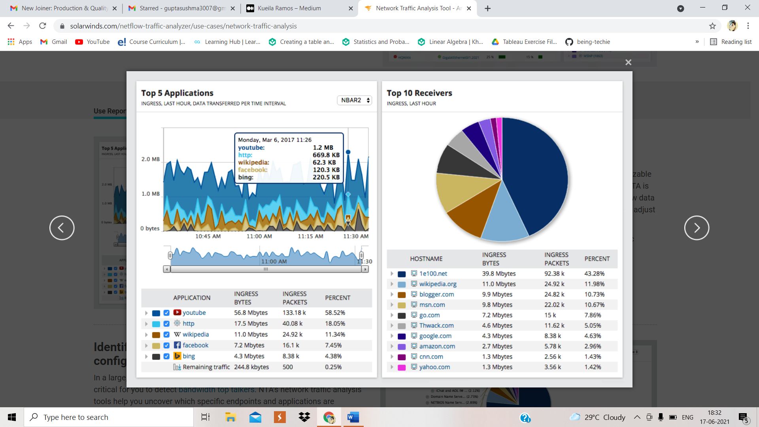

Assignment 1:

You have received the below mail from your CEO and you have to respond to that

mail.

Hi,

Our portal is live and it’s been quite some time now. Could you please help me in understanding

from where the bulk of our website sessions are coming from?

I want to see specifically breakdown of UTM source, campaign and referring domain.

Cheers!

From CEO,

Date: 12th April 2012

Solution:

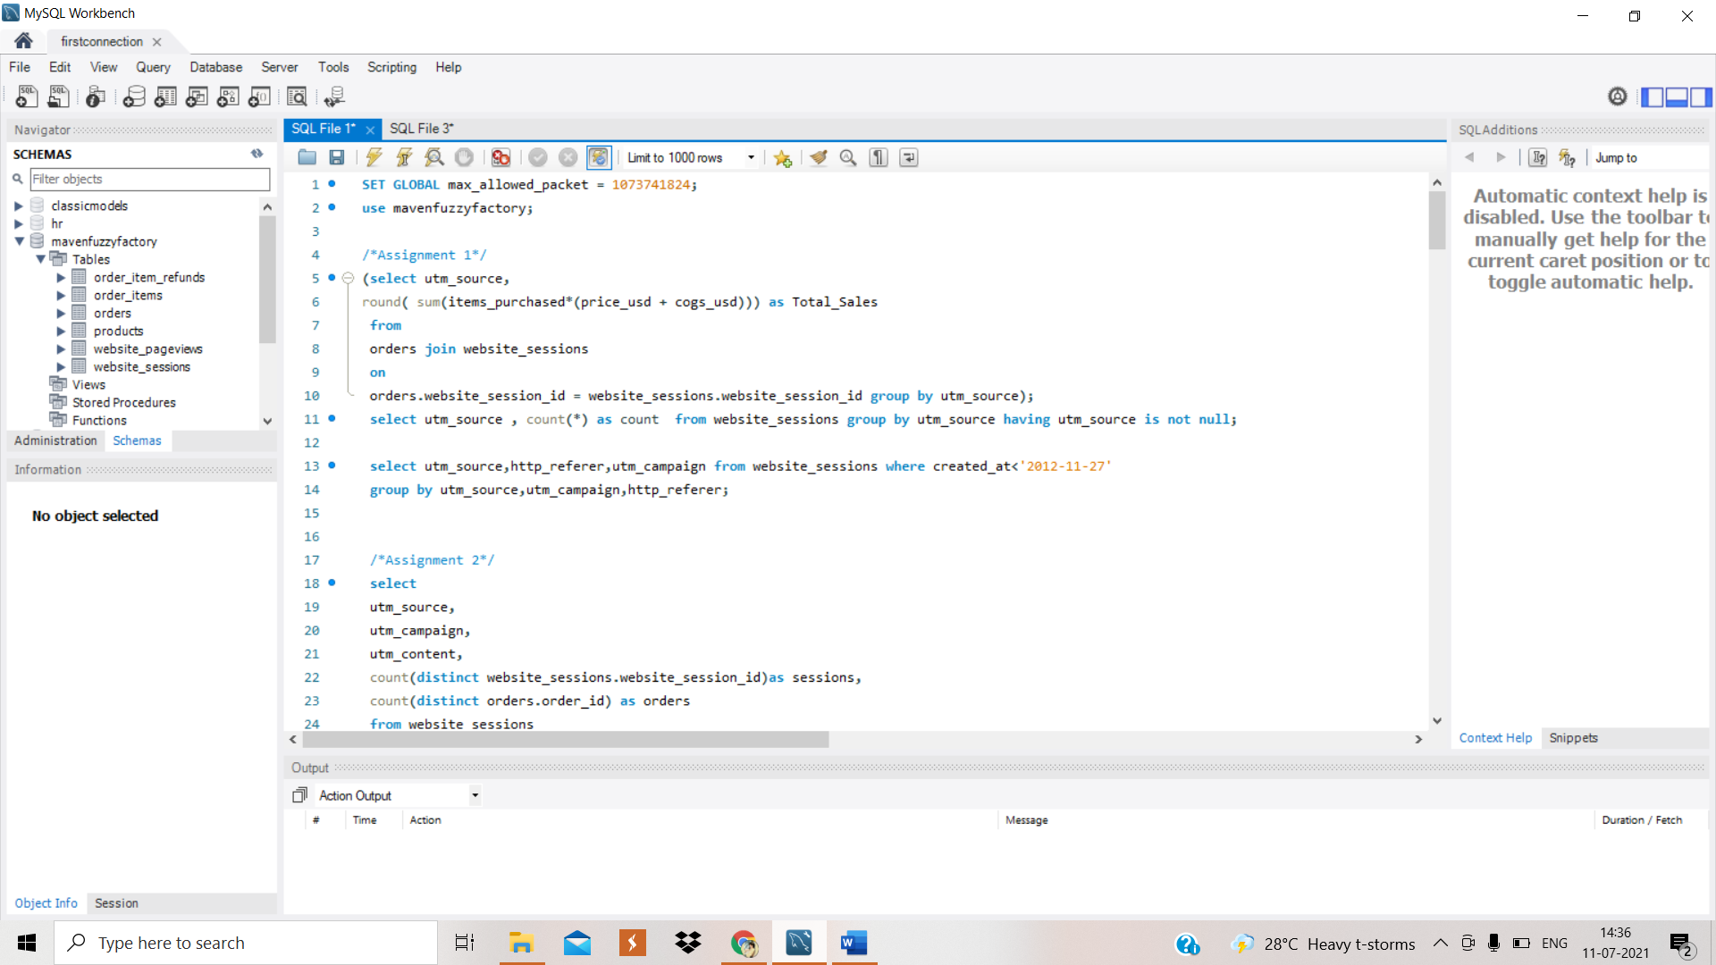

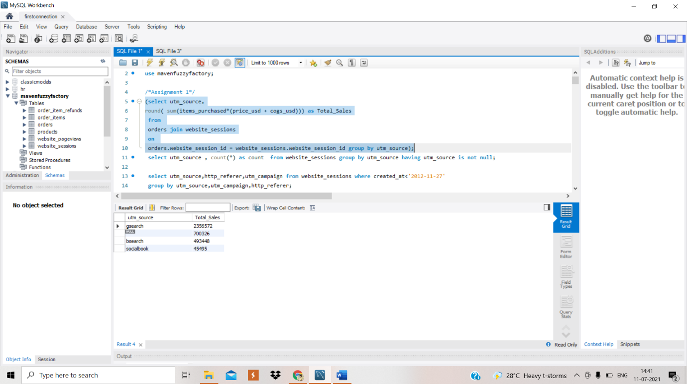

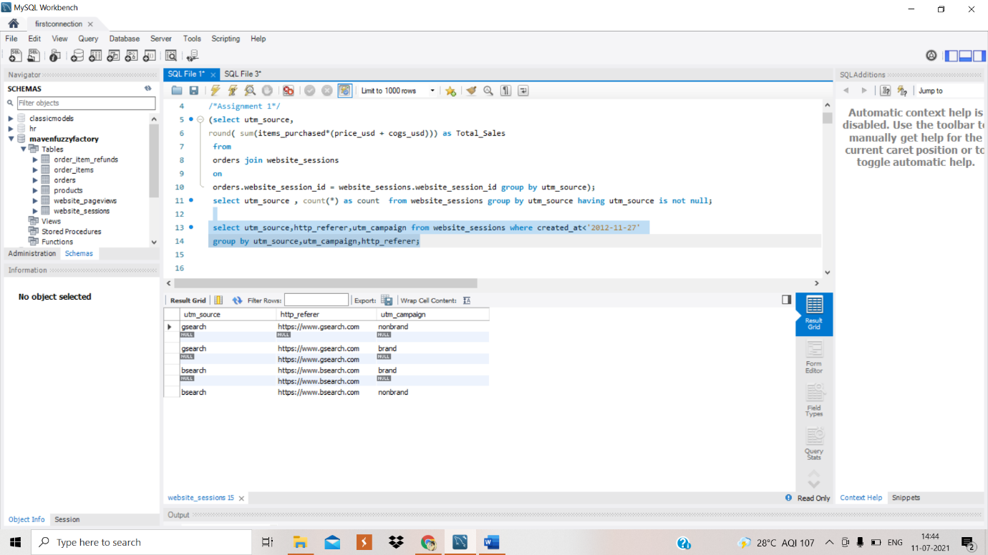

* Bulk sessions of our website are coming from gsearch

**Reply:**

Hi,

I have done the analysis for the same and have come up with a conclusion that gsearch is the source from where the bulk of your sessions are coming with a count of 316035

I have done the breakdown of your UTM source, campaign and referring domain and the inference from the same is that clearly **gsearch**source, from **nonbrand**campaign category, contribute to the highest sessions followed by the null value which corresponds to traffic not paid while **socialbook** with **pilot** has the minimum count

From : Sushma Gupta

Date: 17 June 2021

Assignment 2:

It looks like gsearch nonbrand is the major traffic source, but we need to understand if we are get

sales out of it.

Is it possible for you to calculate the conversion rate from session to order?

We will require to manage bids based on CVR

Cheers!

From EA - CEO,

Date: 14th April 2012

Solution:

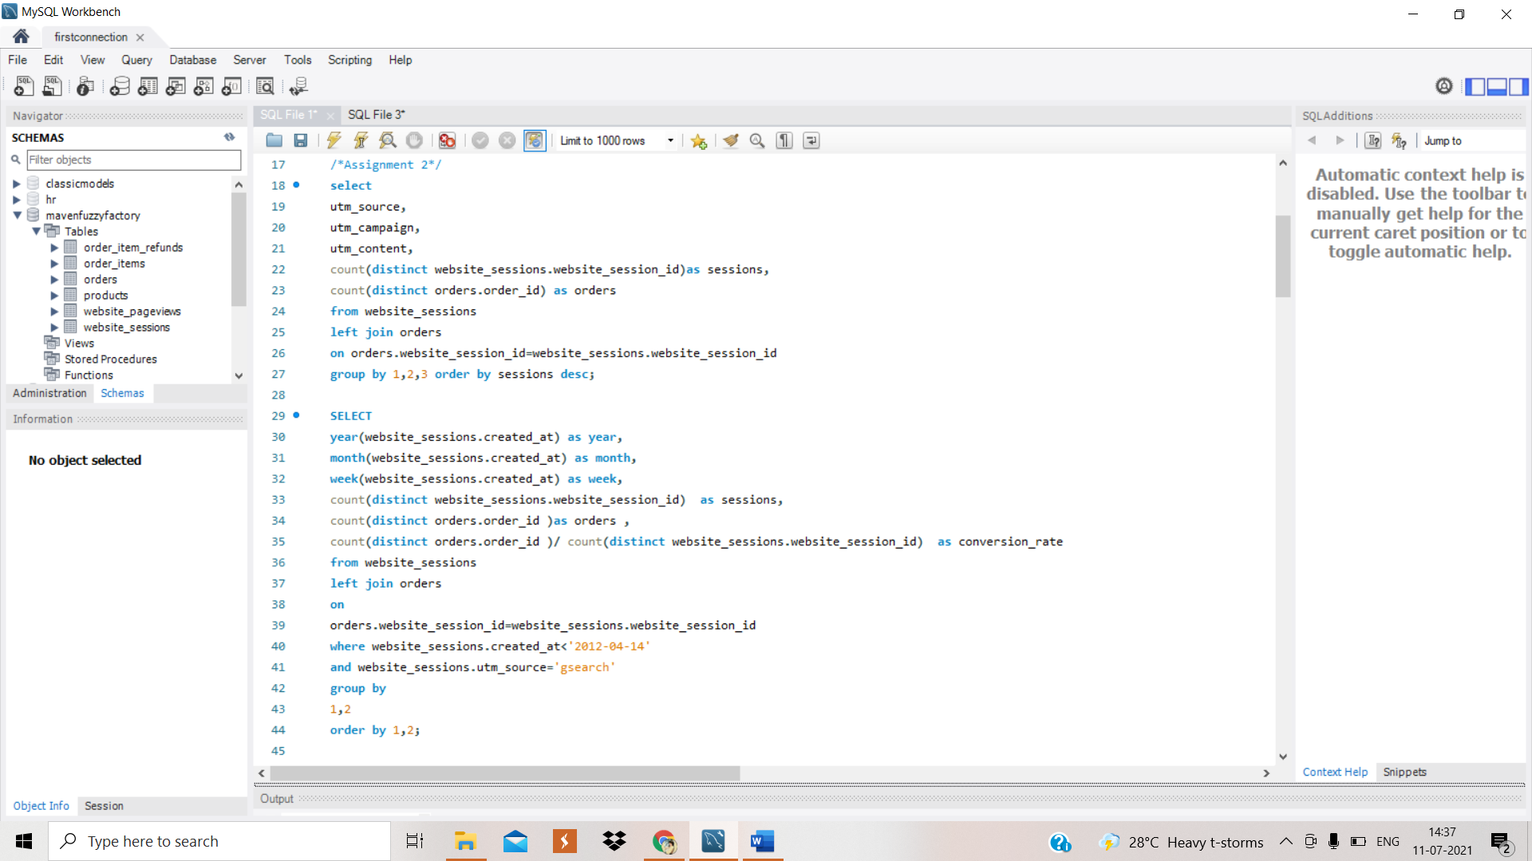

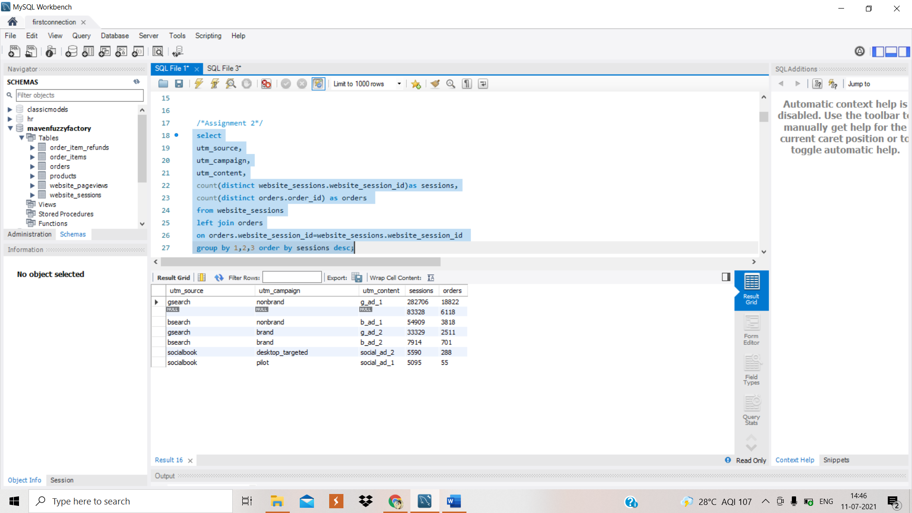

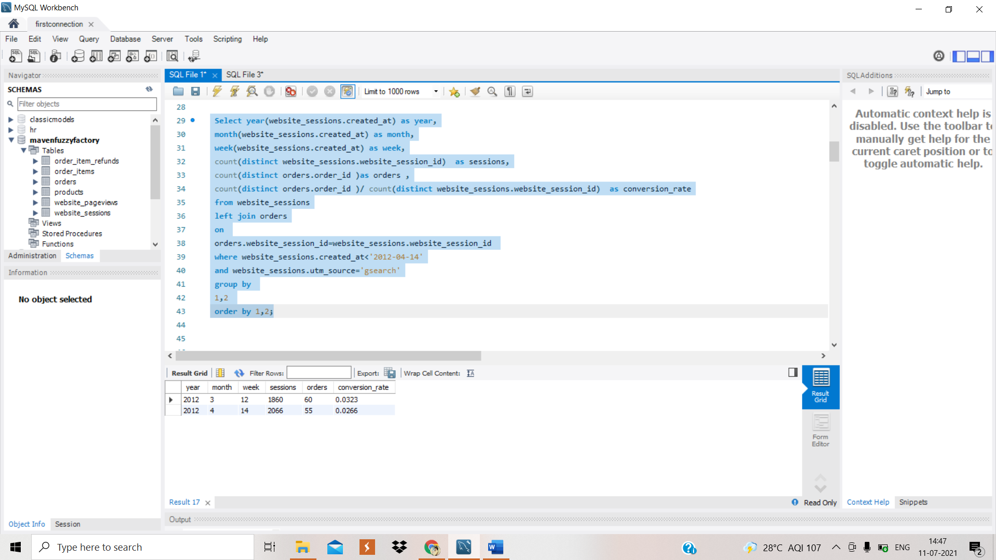

**Reply:**

Hi,

After getting the insights I got to a conclusion that gsearch has total sales of 2356572

Over time both sessions and orders are increasing. But from these values, we can also see that a lot of users that visit the website, few are actually making a purchase (order). In the perspective of conversion rate, we see an increase from 3% in 2012 to 7% in 2014, this doesn't mean that the sessions are turning into sales. This means that traffic is not resulting in more sales. Instead, it results in ad spend derived from the paid campaign .So for our example,our website received 282,706 sessions from *gsearch nonbrand*and was made 18,822 orders.

Branded- with brand name

Unbranded- without brand name

From: Sushma Gupta

Date: 17 June 2021

Assignment -3:

Hey,

Based on our last conversation where we analyzed conversion rate, we bid down gsearch non brand

on 15th April 2012 because we were over bidding for g search non brand.

Now, can you find gsearch non brand trended session, volume by week to see if the bid changes has

caused the volume to drop at all?

From Marketing Director,

Date: 10th May 2012

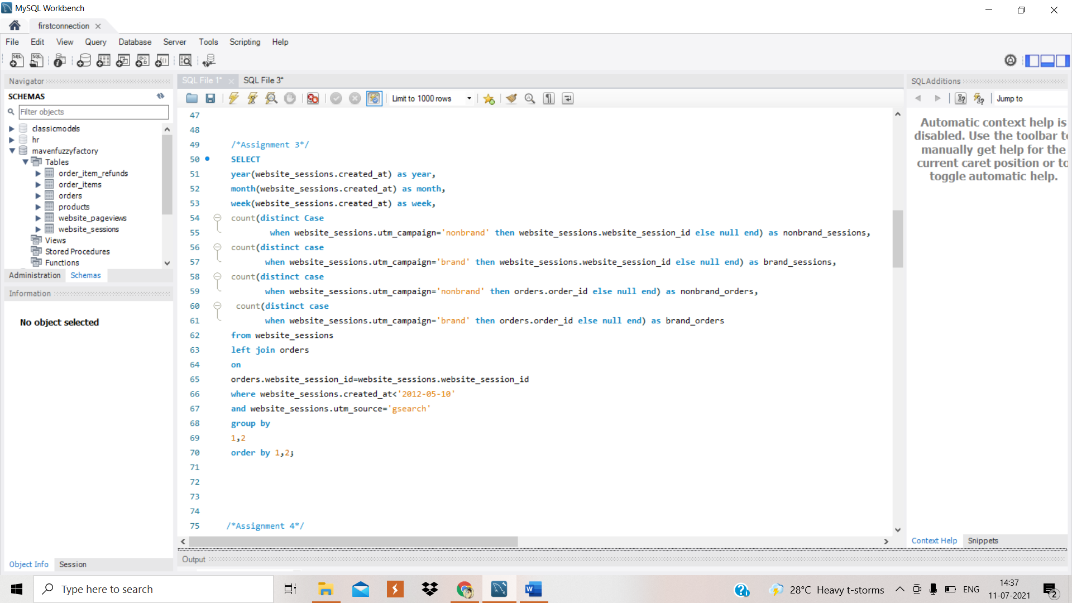

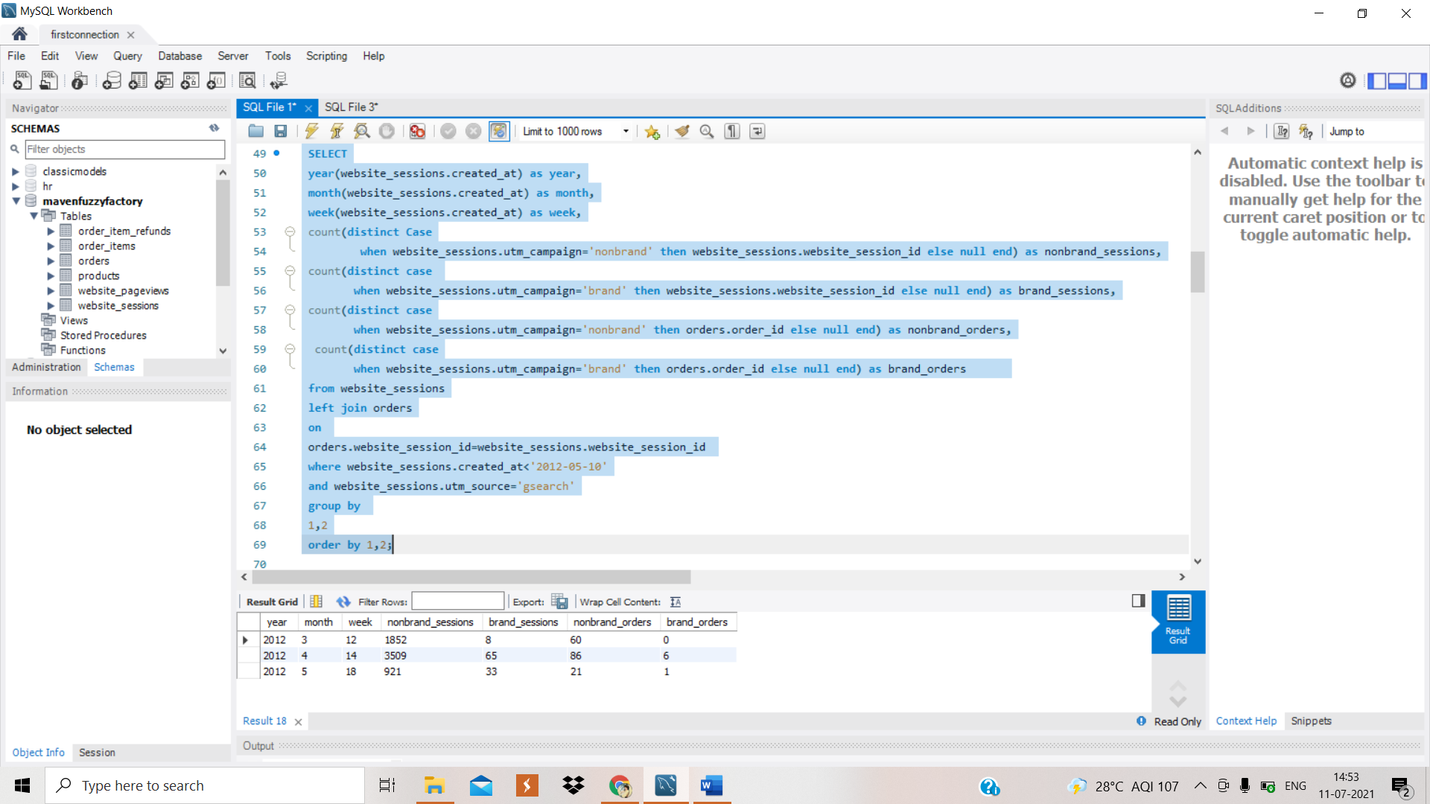

Reply:

Hi,

After getting the insights I have come up with the conclusion that

Besides our visitors are searching from our paid *gsearch* engine, these visitors may not know about our brand name and accidentally they find our website by searching a product in those engines. That’s why*nonbrand* traffic has a higher number of sessions than *brand*traffic .For those who know the *brand* of our e-commerce company, besides the increased session over time, it still very low compared to nonbrand session.

From : Sushma Gupta

Date: 17 June 2021

**A/B testing**

A/B testing is a user experience research methodology. A/B tests consist of a randomized experiment with two variants, A and B. It includes application of statistical hypothesis testing or "two-sample hypothesis testing" as used in the field of statistics

A/B testing (also known as [split testing](https://www.optimizely.com/optimization-glossary/split-testing/) or [bucket testing](https://www.optimizely.com/optimization-glossary/bucket-testing/)) is a method of comparing two versions of a webpage or app against each other to determine which one performs better. AB testing is essentially an experiment where two or more variants of a page are shown to users at random, and statistical analysis is used to determine which variation performs better for a given conversion goal.

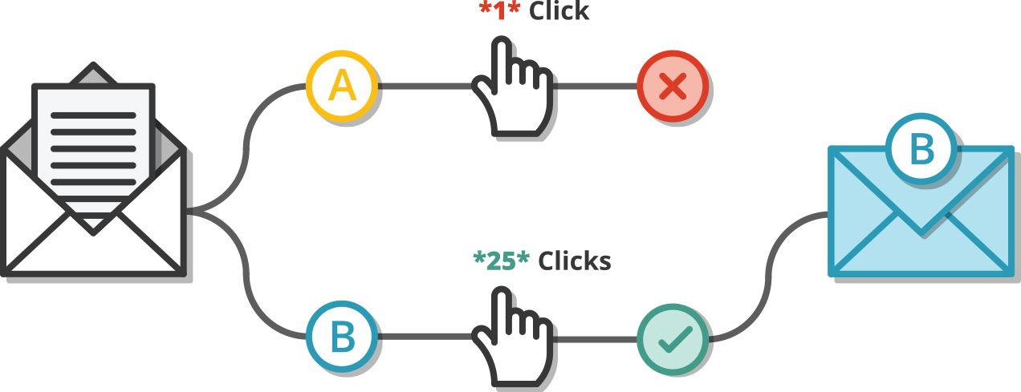

In an A/B test, you take a webpage or app screen and modify it to create a second version of the same page. This change can be as simple as a single headline or button, or be a complete redesign of the page. Then, half of your traffic is shown the original version of the page (known as the control) and half are shown the modified version of the page (the variation).

As visitors are served either the control or variation, their engagement with each experience is measured and collected in an analytics dashboard and analyzed through a statistical engine. You can then determine whether changing the experience had a positive, negative, or no effect on visitor behavior.

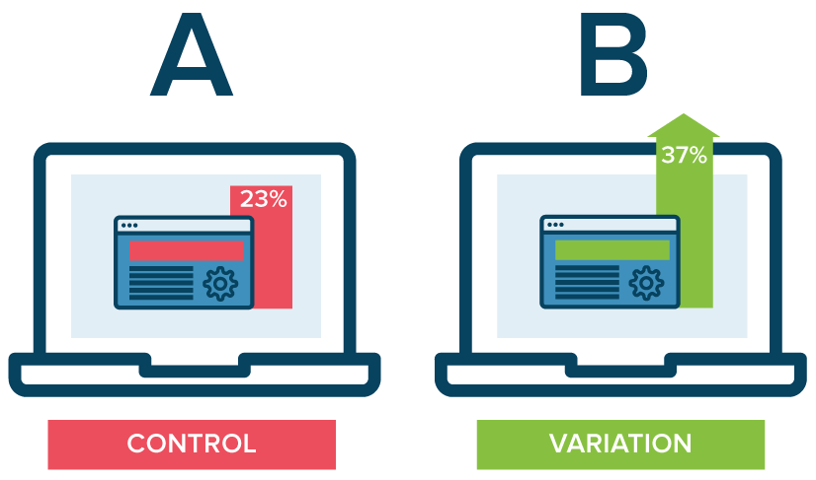

**Use:**

A/B testing allows individuals, teams, and companies to make careful changes to their user experiences while collecting data on the results. This allows them to construct hypotheses, and to learn better why certain elements of their experiences impact user behavior. In another way, they can be proven wrong—their opinion about the best experience for a given goal can be proven wrong through an A/B test.

**Assignment 4:**

Hi there,

I was going through the mobile and realized that the UI is not that great, I did not have the

satisfactory experience.

Can you figure out the conversion rates from session to order by device type?

In case the performance is better for desktop then we will bid more for desktop to bring more

volume.

From Marketing Director

Date: 11th May 2012

Solution:

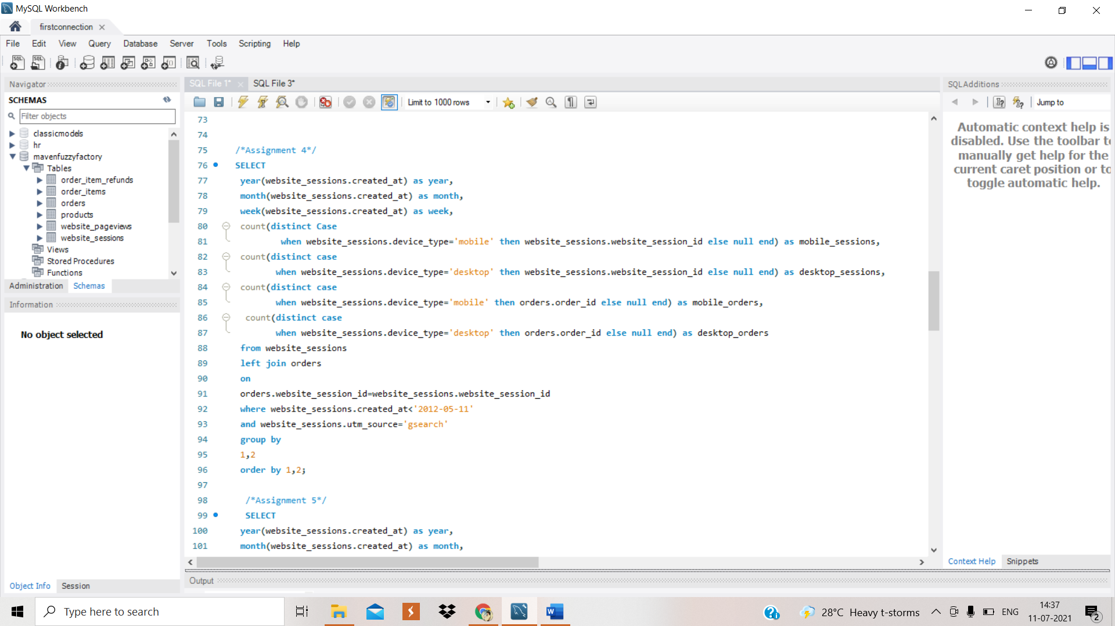

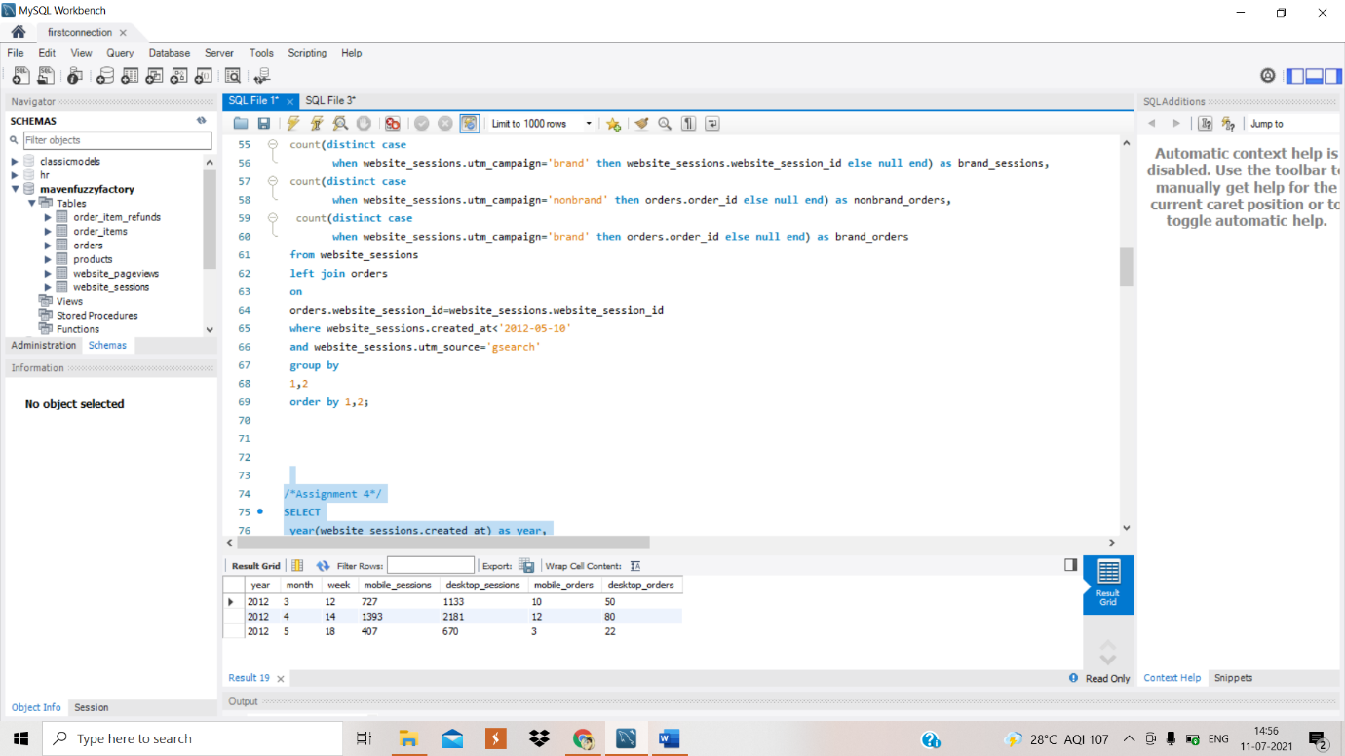

**Reply:**

Hi,

What we can interpret from the result table, is that desktop is being by far the channel that users majority use to access the website. However, this doesn't turn the session into sales. We have users that access our website by using desktops however the orders are extremely low compared to the session.

From: Sushma Gupta

Date: 17 June 2021

Assignment 5:

Hi There,

Based on device level analysis of conversion rates, desktop was doing well, so we raised the bid for

gsearch nonbrand desktop on 19th May 2012.

Can you figure out weekly trends by device type to see the impact on volume?

Baseline: 15th April 2012.

From Marketing Director

Date: 9th June 2012

Solution:

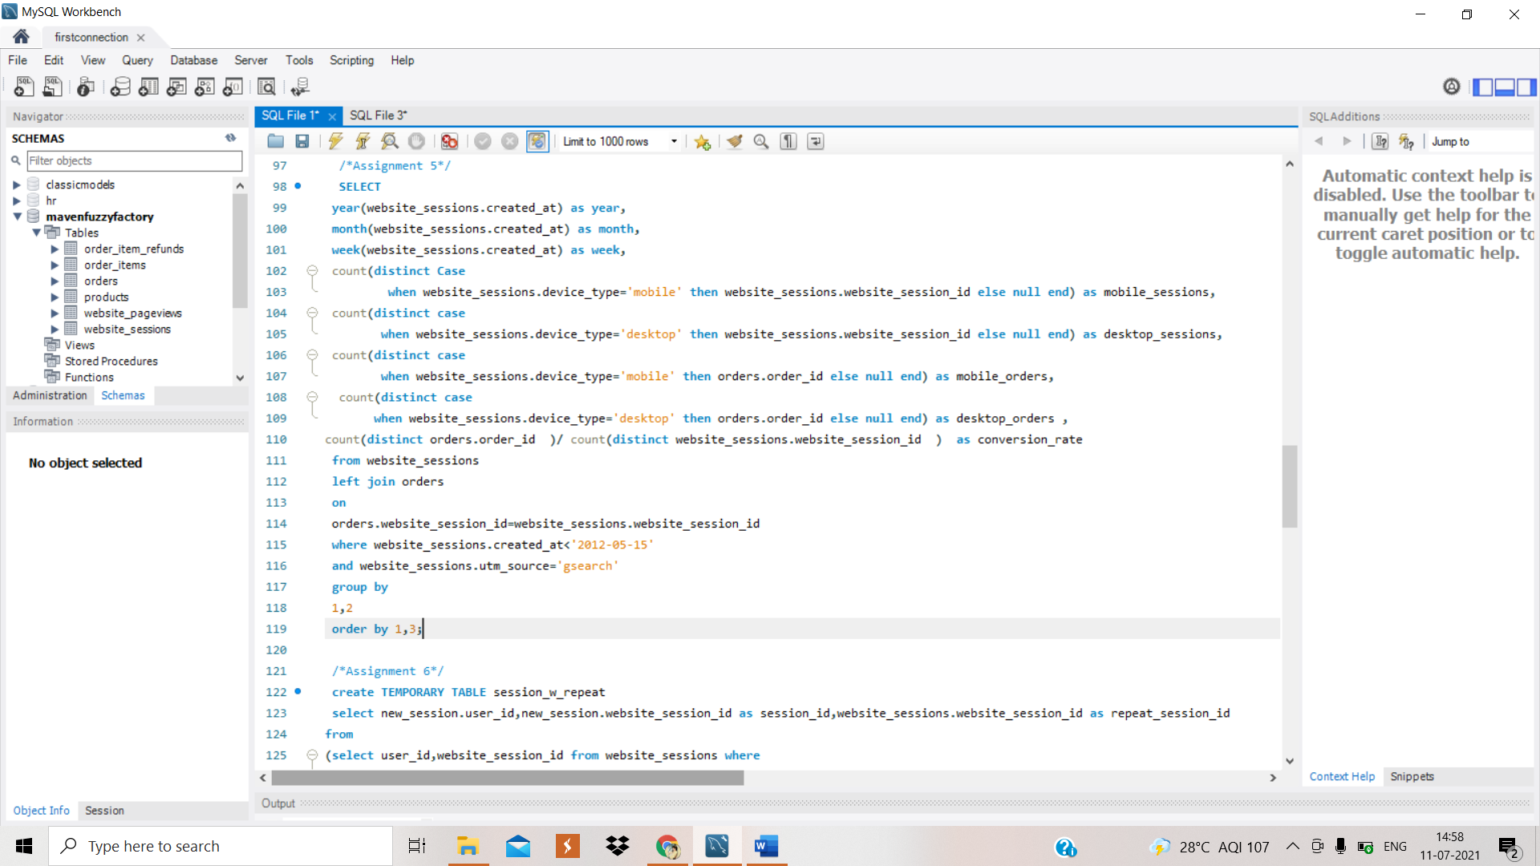

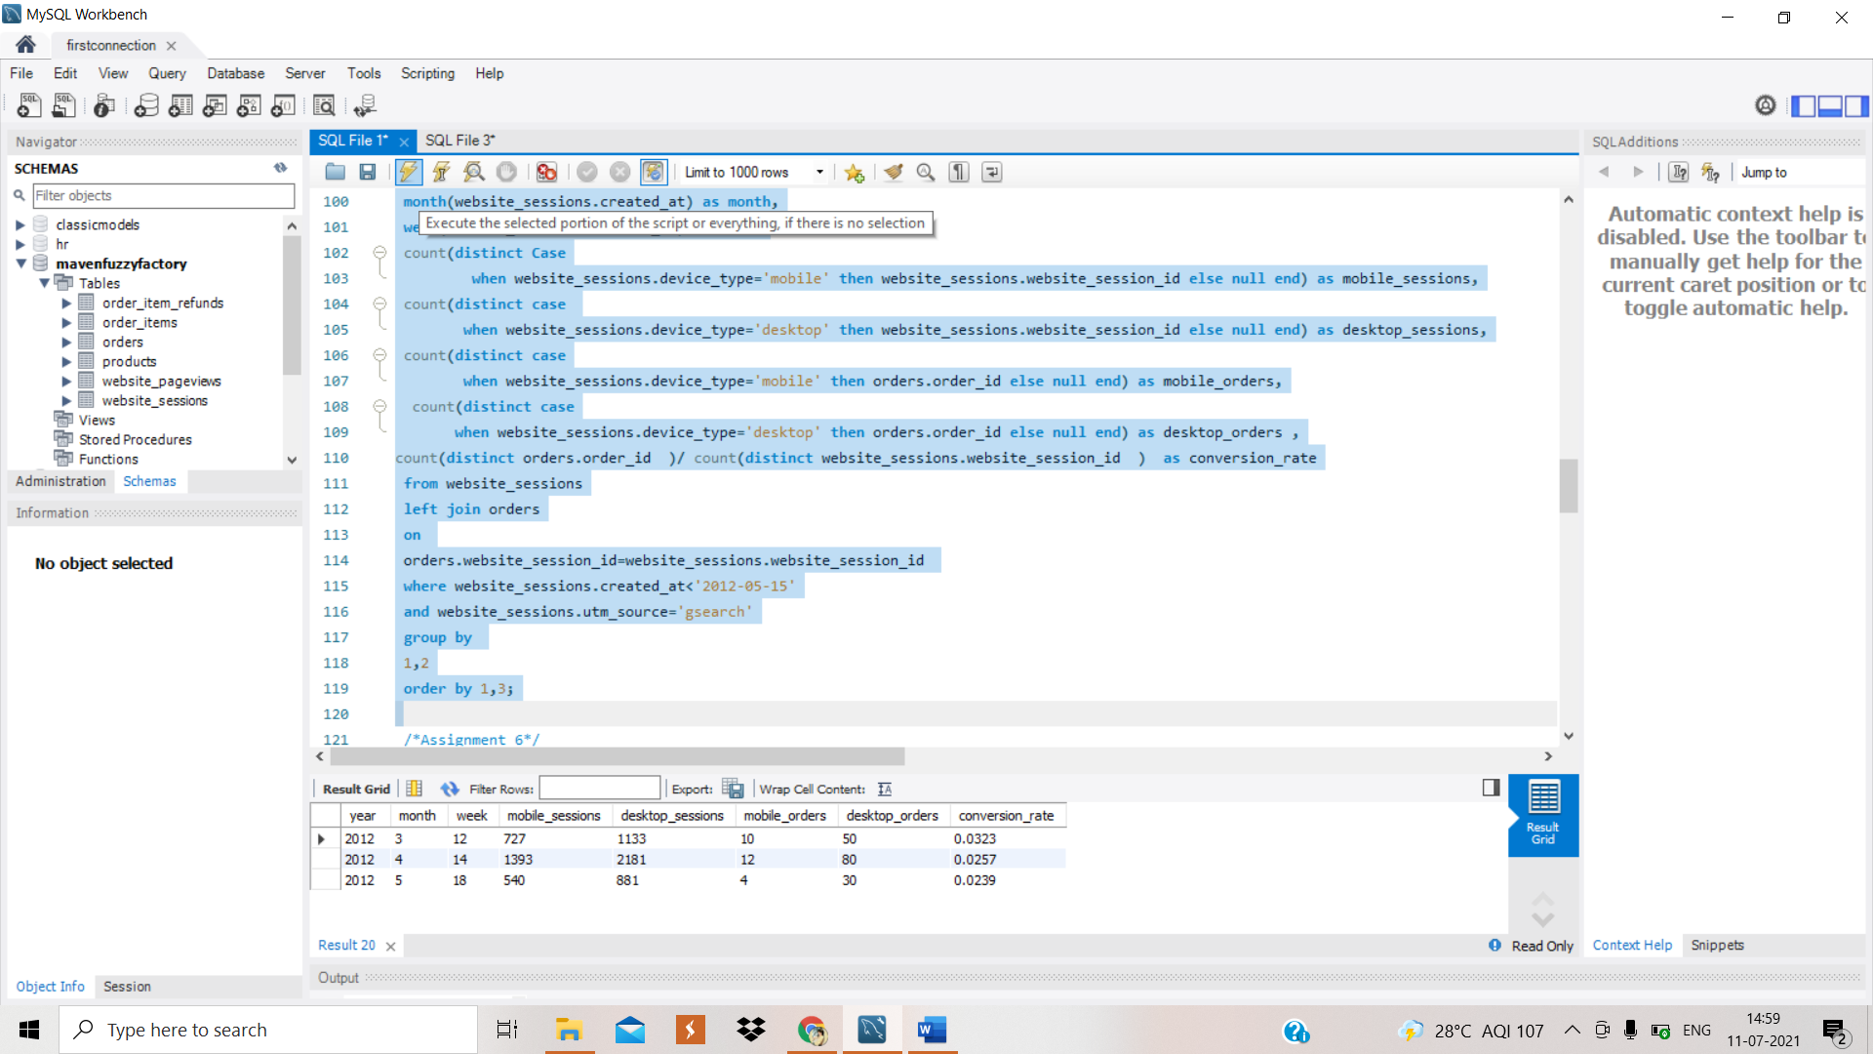

Reply:

Hi.

If we see the weekly trend then on a weekly basis mobile sessions and desktop sessions are increasing across the years while the orders of both mobile and desktop are fluctuating throughout the years.

From: Sushma Gupta

Date: 17 June 2021